Algorithms for Causal Reasoning in Probability Trees

WANG Zinuo, PAN Huangyu
Abstract
In this report, we will describe a mixed technique for finding causal relations, using the combination of probability trees and PC (Peter-Clark) algorithm. Probability trees provide a straightforward, top-down representation of conditional probabilities, and the PC algorithm extracts causal connections automatically from data using conditional independence tests. Based on a health dataset from [1], we illustrate how combined use of these two techniques provides richer and more easily understood causal data. The combined solution can help determine directionality of relationships found in probability trees and give statistically stable causal graphs. Scalability and complexity have not been addressed yet, but the combined approach has potential applications in medical diagnosis, economics, and beyond.

1 Introduction
Causal reasoning is not about discovering associations, but how a variation in one variable affects another. The standard statistical correlation analysis can’t provide these direction signals. Both probability trees and the PC algorithm have a good, but slightly different, take on this problem.
Probability trees are hierarchical branched structures of joint probability distributions. Each branch represents conditioning on a variable, and the ends are joint results with associated probabili17 ties. This hierarchy is straightforward for illustrating how multiple variables influence the odds of 18 various outcomes, in order.
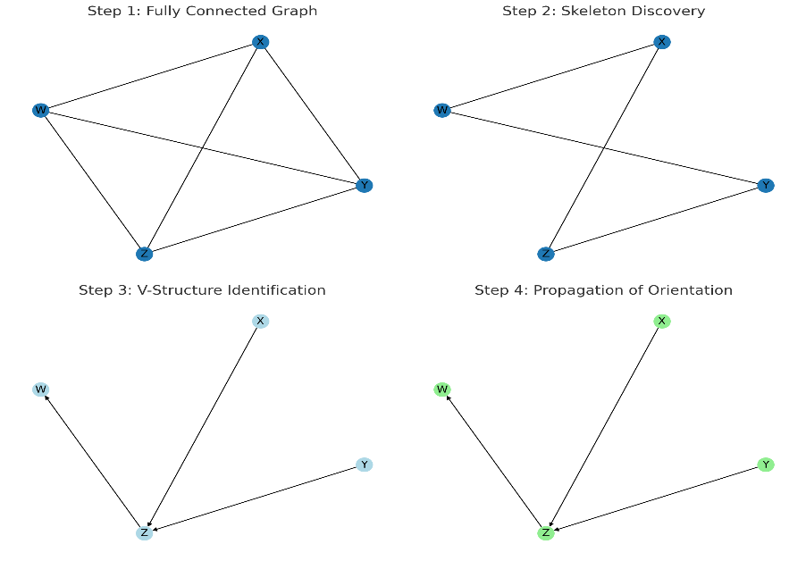
Figure 1: The conceptual steps of the PC Algorithm.
From left to right: (1) Fully connected graph; (2) After independence tests, some edges are removed; (3) V-structures identified; (4) Edges oriented to form a causal structure.

PC Algorithm is an established method of learning causal structure. Figure 1 shows the four steps to apply PC algorithm. It starts with a connected undirected graph and uses conditional independence tests to trim non-statistically supported edges. It then picks up V-structures (geometry that orients edges), and then returns a partially directed acyclic graph, encoded as a possible causal direction.
We will integrate the combination of these two methods in this report. We use the natural fallout from a probability tree and the statistical structure calculated by the PC algorithm to find a clearer picture of causality. The combined method allows us to see which lines of the probability tree are backed by independent tests and thus gives us more confidence in inferred causal pathways.

2 Methodology and Implementation
We apply these methods to a health-related dataset described in [1]. The dataset, named “Ddxplus,” includes variables such as Smoking, Obesity, Diabetes, Hypertension, Chest Pain, Shortness 30 of Breath, NSTEMI/STEMI (a form of heart attack), and Healthy status. Prior to analysis, the data is assumed to be cleaned and discretized for compatibility with both probability tree construction and the PC algorithm. And there are three steps for the implementation to combine probability tree and PC algorithm.

2.1 STEP 1: Creating the Probability Tree
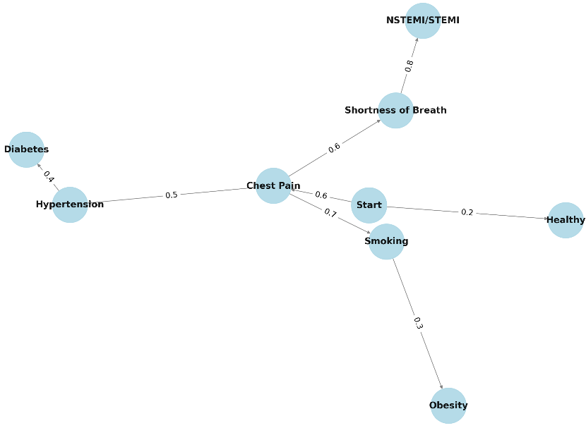
Figure 2: Probability Tree of the Health-Related Dataset
Branches correspond to conditioning on specific variables, showing how probabilities unfold step-by-step
Figure 2 is the probability tree we built to see the probabilistic relationship between these health variables from the dataset we have found. In each branch we can check a variable to see how it affects the other branches. Thurs, we can have a taste of the relationship between them but it is not deep enough.
2.2 STEP 2: Applying the PC Algorithm
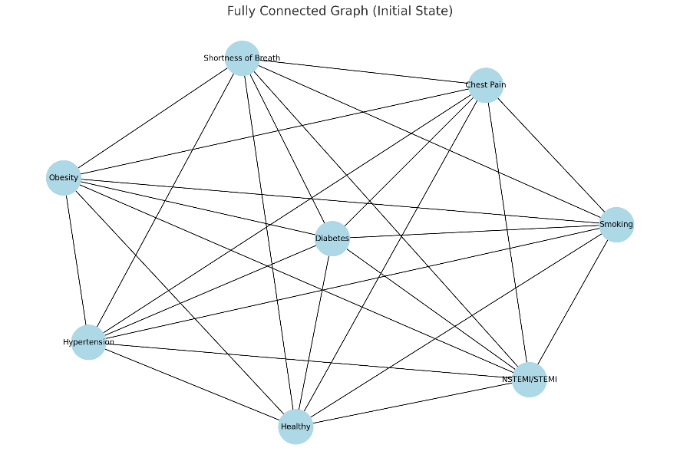
Figure 3: Initial Fully Connected Graph of Health Variables
All variables (Smoking, Obesity, Diabetes, Hypertension, Chest Pain, Shortness of Breath, NSTEMI/STEMI, Healthy) are interconnected.

Figure 3 is an Initial Fully Connected Graph: Before the PC algorithm’s independence tests, we start with a fully connected graph of the health-related variables as mentioned in the introduction of the PC algorithm. Every variable is initially connected to every other, representing the maximally uncertain scenario. This is the first part of this step.

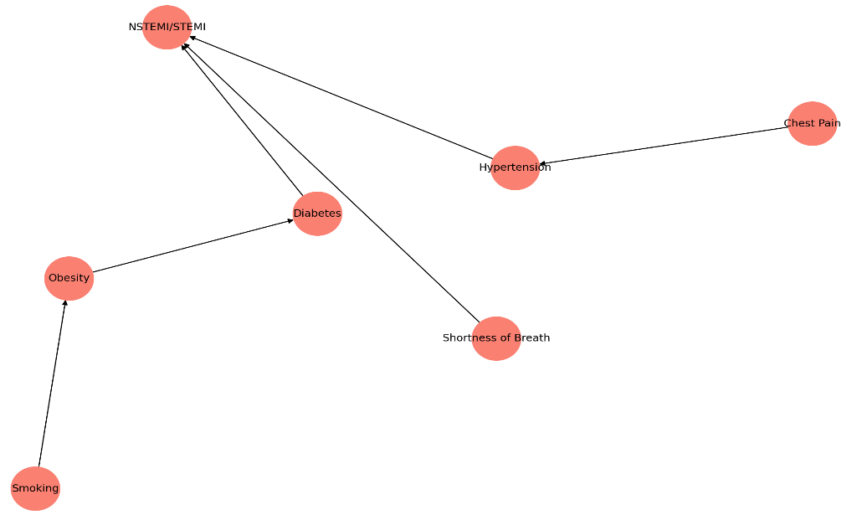
Figure 4: Resulting Directed Graph After Applying the PC Algorithm
A sparser network with oriented edges, representing candidate causal pathways among the health variables.
Based on the first part, we perform conditional independence tests on the fully connected graph. The independence tests use the data given by the probability tree drawn in the first step, so the probability tree from our first step plays a great role in this step. Edges that fail these tests are removed. The algorithm identifies V-structures and orients edges, producing a directed graph that suggests plausible causal directions. What is left at the end is Figure 4.
2.3 STEP 3: Complex Causal Graph Interpretation
By examining the probability tree and the PC-derived graph together, we gain richer insights. Suppose the probability tree shows that as Smoking increases, the likelihood of Obesity also increases, and given Obesity, the probability of Diabetes rises. If the PC algorithm’s resulting causal graph similarly indicates a chain of Smoking → Obesity → Diabetes, we have a coherent picture from both the intuitive probability breakdown and the rigorous independence testing. This coherence increases our confidence that relationships are truly causal rather than coincidental. Of course that's only part of the conclusions we can see from this chart, look at another chain of relationships Chest Pain → Hypertension → NSTEMI. We can also find the Chest Pain and NSTEMI( a type of heart attack) may have some links.
While the PC algorithm alone provides a statistically sound causal graph, it can be abstract. The probability tree makes relationships more tangible and understandable. Together, they blend intuitive insight with statistical rigor, making it easier to communicate and justify the inferred causal structures.

3 Discussion
3.1 Comparison with Traditional Methods
Where other causal inference methods (e.g., Bayesian networks, structural equation modeling) use only models of abstract kind, the probability trees-PC algorithm combines both easy visualization and statistical accuracy. This can be more interpretable and give us confidence in causal implications.
3.2 Shortcomings and Limitations
When the data is very big, or you have lots of variables probability trees become boring and PC algorithm independence tests are computationally expensive. Strong in noisy environments and complexity scaling will be more research questions.
3.3 Real-World Applications
When it comes to medicine, it’s crucial to know which causal factors have causal effects on disease. When clinicians and researchers can harness these combined techniques, they’re able to better determine risk factors and create interventions. The same advantages hold in economics, social science and engineering – any field where causal mechanisms must be worked out to make informed decisions.

4 Conclusion
In this report, we showed a method that combines the natural illustration from probability trees with the powerful causal structure inference of the PC algorithm. Experimenting with the technique on a health dataset from [1] illustrated how pairing the two can lead to more interpretable and well-evidenced causal models. While still hard work (especially scaling and complexity), this coordinated approach has promise for better understanding of causality across disciplines.

References
[1] Fansi Tchango, Arsene, et al. ”Ddxplus: A new dataset for automatic medical diagnosis.” Advances in Neural Information Processing Systems 35 (2022): 31306-31318.
[2] Spirtes, P., Glymour, C., & Scheines, R. Causation, Prediction, and Search. MIT Press, 2000.
[3] Pearl, J. Causality: Models, Reasoning, and Inference. Cambridge University Press, 2009.
[4] Koller, D., & Friedman, N. Probabilistic Graphical Models: Principles and Techniques. MIT Press, 2009.
[5] Neapolitan, R. E. Learning Bayesian Networks. Pearson Prentice Hall, 2004.
[6] Jordan, M. I. (Ed.) Learning in Graphical Models. Springer, 1998.

